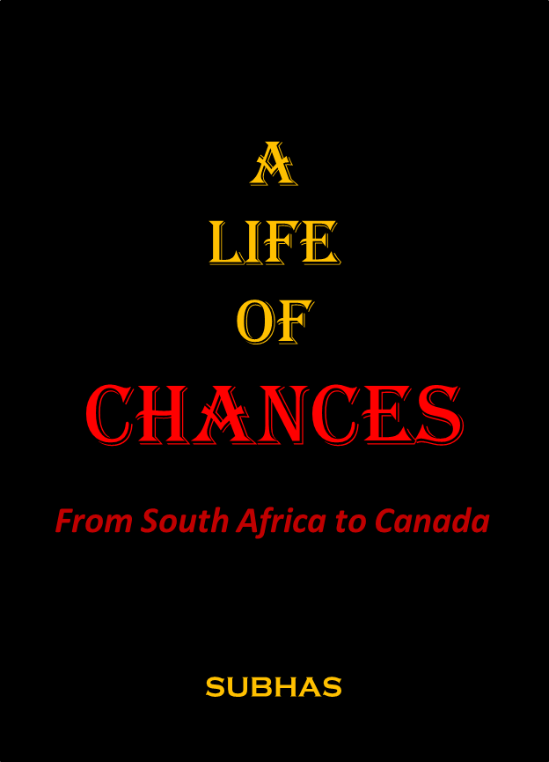

Stars create patterns in imagined minds,
And imagined minds decipher destinies.

I escaped from South Africa
where the clash of cultures and colour
continued the ignominious history of man.
My experience in Canada is
the Bitter-Sweet Song of Human Frailty.

Life offers many chances and if taken they are opportunities for new visions and horizons, and for expanded ventures.
Subhas left South Africa where the clash of cultures continued the history of man, and where race and skin colour were limits to aspirations. It was a chance accompaniment that introduced him to theatre and acting although he did have a very distinct voice quality.
Subhas completed his under-graduate studies in South Africa and a Diploma in Speech Therapy in South Africa through Trinity College, London.
He acted in Golden Boy and many productions at University. Subhas produced and directed Waiting for Godot when he was 21-years old and was demonized by the white theatre professionals and other intellectuals. He was best-known for the productions of Black on White I and II satirizing the socio-political-economic conditions of the apartheid system. This venture attracted the attention of the citizens and the Government of South Africa.
Through his writings and productions he met Fatima Meer and was in the final process of editing her book, A Portrait of South African Indians and had completed writing the first half of A Pageant on the Life of Mahatma Gandhi with Alan Paton, Cry the beloved Country, South Africa’s International Writer, when he was forced to leave in 1969.
It was Fatima Meer who informed him that he was on the list of the Bureau Of State Security (BOSS). In terse language she said, Subhas you have to leave. They’ve got you and drove off. An Uncle arranged, in short notice, for a ticket to Toronto. He had 6-days to leave South Africa and did not have a visa to enter Canada, but that was the chance and he had to take it.
He was interrogated at the airport in London with the threat of being deporting to South Africa; however, his arguments and tenacity prevailed. He was given a 30-day visitor’s visa to stay in London. He flew to Toronto and received the same backroom ‘conference’ but it was less harrowing. Subhas was given a 30-day visitor’s permit to stay in Canada.
Destiny and chance guided him to Regina. His options were limited – either find a job and hope to stay in Canada or look for another country. He had 10-days to his credit when he was welcomed as a landed immigrant and began his career as a Speech Therapist in Canada with $1.40 in his pocket. Subhas completed a Master’s Degree in Speech-Language Pathology and continues to work in that capacity in Saskatchewan, Canada.
He designed and developed the Pictogram Symbols Program, a visual communication strategy which is used internationally. He has created many educational and community-based items using the symbols. His books, the Dignity of Symbols & PICTOGRAM SYMBOLS: For All Ages are available on his website.
Subhas has published the IMAGINATION DRIFT Trilogy: A Prince for Three Days; The Challenge and Space Evermore; A documentary novel, On a Dusty Road – The Life and Death of a Young Man, 2-books of poetry, In a Mind Darkly and Looking for an Open Sky and 3 unpublished plays.
In 2018 he began a program providing vitamins to children whose families access the Food Bank in Rosetown and hopes the concept will embrace other communities. He designed T-Shirts with Pictogram Symbols to support Health & Education programs for children. The shirts are available through www.ourhopeinaction.com
Subhas has chronicled his young days in South Africa and the many encounters in Canada in A Life of Chances
He has been a Councillor and the Mayor of the Town of Rosetown, Saskatchewan, on two occasions.

CHAPTER 1
Look at the circle drawn
and the free hand shake
as it moves over the crusty surface.
Look with sharp eyes
and endure the vague lessons
emerging from the cocoon
and smell the smells of a passing life.

As I turn to gaze in silence
at blurred images
my enclosure has produced a brown moth
to be nurtured on human thought
and awaken
The Age of a Blank Slate

THE IMAGE
The shadows of time amaze me. I should never have survived a long life. I should never had wriggled my way out of the mental dungeon of South Africa challenging the dark chasm of restlessness and the loneliness of being alone. I raised my eyes to the stars for comfort and asked, Was it a path that was engraved in my destiny to be saved from human torture? Was there a purpose or just a tanned face in the sun to be trampled under the boots of indifference?
The story of survival was to cower to the sight and sound of the white settlers who had usurped the land and the authority through guns, violence and death. I was lucky. When I turn the pages in my mind I shudder. I should have been incarcerated, killed, cremated and blown as the dust of the loose Earth.
I was not a soldier of the movement. I had no background, no mentor, no group to join as a unified voice. I was too puny to be considered a threat but I understood the power of the spoken and written word. Oppressors, from the story of man, have always feared the thinking-man, the man who can change ignorance and brutal survival to human aspirations. I stood on the fringes observing, learning and summarizing my own conclusions that reactionary politics was for old men cleaning their conscience of the social inequities in a racially divided South Africa.
On many occasions I was offered sticks of dynamite to prove my metal and my conviction for social change. An explosion to prove that I stood against the vicious and vulgar concept of apartheid. I resisted the aspect of violence and realized that violence engenders violence and that brutality will be met with brutality. There had to be another human way to coexist. I had the ability to conceptualize and translate ideas into simple statements. I could speak clearly and forcefully, that was my gift. But gifts are squandered if they are not understood and nurtured. I asked myself; How did this all happen?

2026

