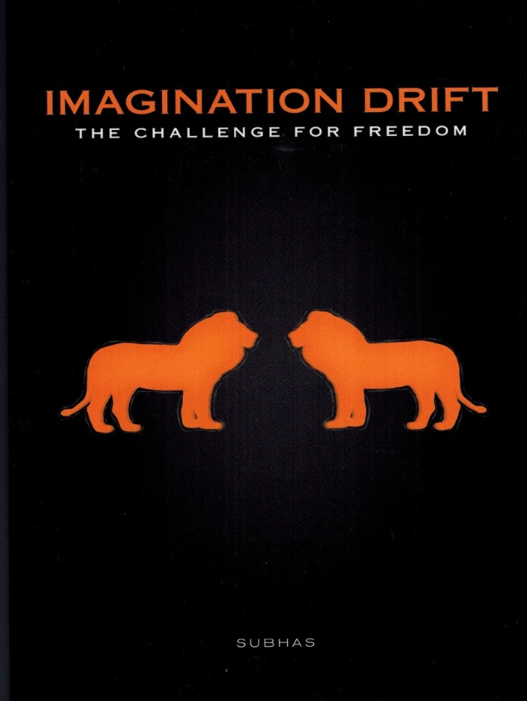

BOOK TWO
THE CHALLENGE

Zalador is given a second chance but he is asked to assist a young lion, the Major, in finding a wish-partner as the requirement for entrance into the Supreme Council.
The difficulty is that there are two lions competing for a single position on Council and this becomes THE CHALLENGE.
Zalador selects a Monkey Princess and is ready to complete the wish.

The Major, an urban lion, claims to have contacts on the Supreme Council and is guaranteed to be the new Councillor. This creates uncertainty and despair that Zalador has to endure.

After much indecision the Major selects an acquaintance of Zalador’s wish-partner, Sta who wants to spend a Day in Paradise. The Urban-Lion displays his knowledge and superiority over the Jungle-Lion but gets the wrong coordinates and lands in Paradise Station and eventually on Paradise Island.
Zalador’s wish-partner wants to experience her day visiting with human-people and she is taken to the Kingdom of Ruain but is disappointed with the devastation and the Spartan nature of the visit.
A Surfer on Paradise Island is infatuated with Sta and in his hopes of seducing her is injured in an accident and subsequently dies.
Zalador is accepted as the new Councilor. The Major is disqualified on a technicality – the death of the Surfer.

Page 1

THE CELESTIAL COUNCIL

This was the time in space; celestial time bonded to the mechanics of mass and no mass; a fraction in the slow movement of endless motion. Zalador had waited for the decision and time seemed to be a long shapeless dream; an interminable sleep and he was about to open his inner self to a shiftless spirit forever or to the timeless waves of power and freedom. Zalador felt a tremor and more tremors shook his weightless frame. He felt a burning sensation move up and down his spiritless shape and he knew that this was the time for the judgement. The lion turned his head towards the depths of the universe hoping that those who could see would accept his gratitude; would understand his humbleness; would forgive his moment of forgetfulness; one moment in a lifetime of glory and now this mind-bending turmoil.
In the midst of his anguish and frustration of not knowing, Zalador dropped his head onto his paws and looked vacantly at the dark void before him. And from the darkness a light appeared and the darkness evaporated. He could see himself as a playful cub; innocent of the wonders and disappointments of growing-up. There he was; a young lion poised to challenge the world; to fight for his place in the kingdom; fight to be the king of the kingdom. Zalador, the King of the Open Earth and Sky; he was victorious and he wanted the echoes to carry his message of victory and dim the aspirations of those who hoped to challenge him. Zalador was in his glory. He sat in his regal pose and surveyed his kingdom. This was Zalador, the mighty ruler; waiting for the decision; waiting for the acceptance; waiting for the waiting to be over.
The light faded into darkness. Zalador inflated his chest with emotion; with anger; with the wrath of madness and he screamed for his sanity. A silent scream that spread through the dark reaches of the universe; shaking orbits and dazzling stars in their own brightness and then he saw a distant explosion; a bright light in the darkness of nowhere.

www.friesenpress.com
2019

