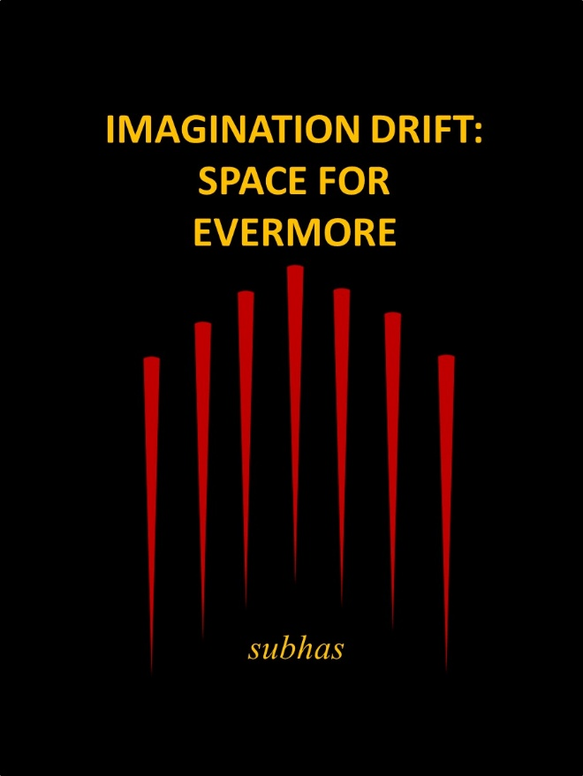
BOOK THREE
SPACE FOR EVERMORE

The details of the Major’s despair of being abandoned as a lost spirit raises Zalador’s concern. He leaves the Supreme Council before being inaugurated as a Councillor to assist the Urban Lion.
This was a very risky move but the old-lion was determined to convince the Major of completing a successful wish and achieving his goal of becoming the Chief of the Galactic Assembly and the Protector of All Lion Spirits.

Zalador struggles to keep the Major on track of finding a wish-partner when the Major requests the transformation into a human-people to complete the wish.
Zalador reluctantly convinces the Councillors of the request and the simple wish turns into an experience of human and alien-people. The Major assumes his stance as a human-people while, to his chagrin, Zalador has to pretend that he is a dog during this encounter.
The Lions are eventually accepted into the Supreme Council and the Major, through calculated manipulation, assumes the position of the Supreme Councillor. However, he wants a complete break from the past and renames the Council the Galactic Assembly.
The Major and Zalador are successful in creating changes to the Assembly but it is the Open-Door Policy of allowing all Lions and Lionesses into the Galactic Assembly. That is their legacy.

Page 1

THE PATH OF Te
The singing lion surveyed the depth of his darkness. Dark minds conjure dark thoughts and fill spaces into the vortex of despair. The spinning of images distorts the frame and the touch-down signals doom. The Major was no different. He surveyed the depth of his darkness. His spirit was spiritless but he had to break his despair and show the lion-spirits of the Supreme Council that he was to be reckoned with. He was not going to be pushed into obscurity; drowned in misery and self-pity. He was not going to be relegated to the dust and the dung of the Plains. He was going to be the catalyst for change and he was going to change the dull thinking and sleepy behaviours of the arrogant and ignorant lot. And as he raised his head he screamed out his emotional energy hoping that the Council members would hear and remember that the Protector was at their door-steps. He was Tagaragara, the Protector of the Pride, and soon to be the Protector of the Universe. He was not going to be stopped by games and arrogance; he was going to fight for his rightful position as the esteemed lion-spirit from the Urban Display Arena; an enlightened spirit from the UDA and the greatest lion of them all
The spiritless lion paced the darkness, looking with pleading eyes at the distant lights of stars and galaxies. He imagined his place and the freedom of manoeuvering galactic waves on a never-ending journey. He was the lion who rose from abandonment to be the leader of a pride of captive lions in the Urban Display Unit. This was an insurmountable achievement for a survivor; a Lucky Lion to be recognized as the best leader of the Urban Display Unit pride. He reflected upon his vacuous wandering; his loneliness as a young cub, a cub who had to be tenacious to survive. Hr remembered how in his infinite misery he let the helpers from the UDA take him to his new home and his safety. He was safe from the hyenas. Tagaragara smiled as he thought of the mangy hyenas; he was safe. He could feel the comfort of being taken to the UDA and moved from one area to another until he was forcibly united with the lions from the unit. These were lions from many prides and he had to be cautious. He was not sure if there were benevolent or malicious gangs and this was a new fear in his new safety.

www.friesenpress.com
2021

