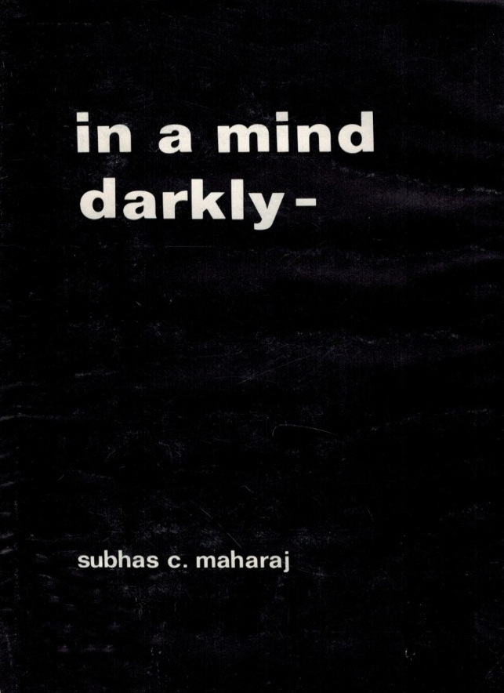
IN A MIND DARKLY

A book of poetry published shortly after Subhas arrived in Canada includes themes of racism and the rigid policies of apartheid. The young mind reveals the despair and frustration against the brutality of the ruling settlers.
The first poem after his arrival in Canada is what Subhas considers his encapsulation of the land of his birth, africa, and the brutal advantages taken in the name of western colonization and civilization.

they fought the whiteman/ who had taken their land
now they fight the whiteman/ who has possessed their lives
There is a passionate plea to end racism in the poem skin colour which ends with the lines: that we can live and love people/without the colour bar game.
Black lives have no significance to the religious morals of the settlers and the hatred is expressed in black dog.
the law of the land protects you/ the white skin rule is strong
so kill a few on sundays/ and take your family along
Subhas settled in the prairies in the winter of 1969 and witnessed the land transform in his poem prairie land.
airy fairy prairie land/sleeping in the sun
you grow/ fields of wheat/in the summer heat
and your work is done
There was still emotion and romance amidst the turbulence of a South African life and in virgo Subhas writes:
we closed in on one another/ displaying nakedness
to the sand and the wind/ and the sky
and we one with the elements
In the description of a fight the broken words and phrases reflect the confusion and futility in an irrational world.
I sit and watch your dementia and ask why

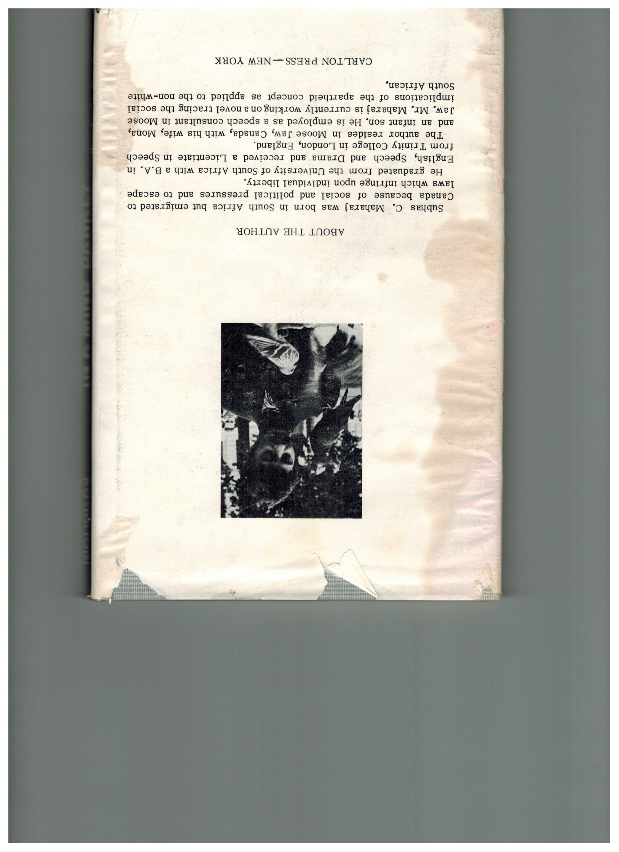

africa

I remember the african flora
and the bare breasted-black females
with bare-bottomed children
strung on backs
licking salty shoulders.

I remember the cow-heard
who dreams of no colour
his days filled with flies
incessantly resting
upon his naked wound.

the pink flesh with yellow pus
contrasts with the black skin
and in all the sunlight of Africa
he sees no light
living among the grass
and the adder and ticks
laughing with the earth
apprehensive of the magic of the stars
restrained by the mythology and ritual
and the prophetic announcements
of the witch doctor.

that was africa in her birth
and her people grew out of her dark womb
dark skinned and joyous
those were the men and women
in the white happiness of the past
luxuriating in her primeval richness
with the sunbaked mud huts
pitched on the african sand.

the old remember the hunts singing songs of battle
on broken reeds
and the ages carried them on.
but that was Africa
bathed by her rivers
and revered by her people.

the rhapsody is over
and this africa reveals a new bewilderment;
they fought the white man
who had taken their land
now they fight the white man
who has possessed their lives
and from the strangulated masses
there still appears a head
and the mouth is silenced
but the dark-skinned hydra
is revitalized
and the shiny armour of the white
reacts viciously.

the wounded black serpent withdraws
to lick her wounds
generated by new impact
and the hot iron
sizzles on the wet flesh
while the dead are buried
without obituaries

and africa?
confused in her rape
allows telephone poles
to dot her breasts
cities to paint her body
and the dead to return to her womb.

1972 – No Longer in publication

