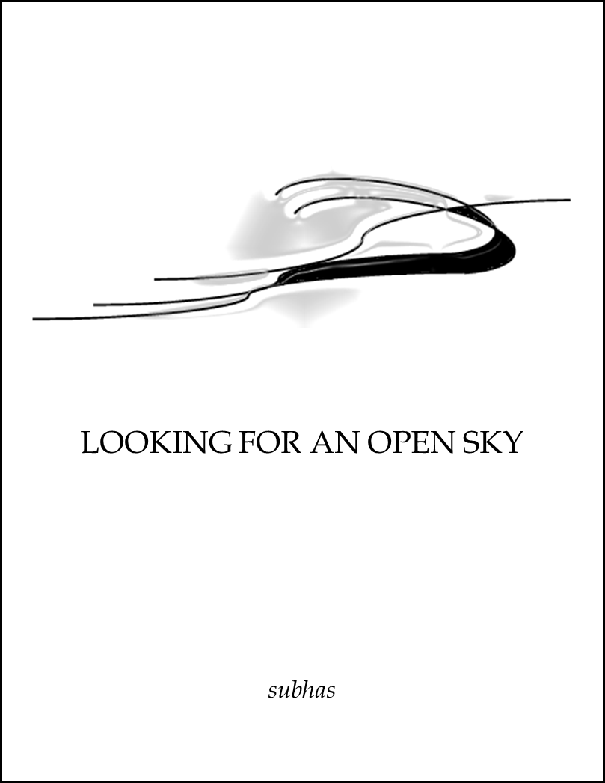
LOOKING FOR AN OPEN SKY is a composition of life caught in the complexity of violence and death; tenderness and affection. Song of an Exile opens with a struggle to break from the past and a tribute to my wife, Mona.
You cannot draw me; out of years of confinement; and solitary meanderings.
I have come not in abandonment or fury to lose my time and discard me.
I have come to feel the future freely.
The poem concludes with;

And to my children? What can I give?
I will give them my vision, my spirit and my song.
The nightmares…. I will keep to myself.
In Madonna a mother comforts her unborn child; Stay in me; stay in my warmth and comfort with me; stay in my skin-shield; and I will nourish you. There is no food and there is no hope and the mother consoles her child;
as I perish; your world will close its eyes
and you will never sit with me;
to look at an open sky.
The poet contemplates the future in the poem Live-on.
Medicate and sedate me; till I’m eighty-three;
give me more till I’m sore; and look to eternity.
But I cannot talk; and I cannot walk; with eyes too weak to see;
hold me still; and force the pill; so I live another dream.
The final poem, africa, was written when the poet left his home country. It is a robust vision of Africa with a sad remenbrance of the land it’s people.
i remember the african flora; and the bare-breasted black females;
with bare-bottomed children; strung on backs; licking salty shoulders.
The poem ends with the sadness and loss of passive innocence; and africa? confused in her rape; allows telephone poles; to dot her breasts; cities to paint her body; and the dead to return to her womb

Doomed

Eat the dirt of the earth to live or die;
the life around is dead.
A little girl in a lonely world
looking for a piece of bread.

The earth is dry, the sky is dry
you gaze at the killing sun.
Cry in pain for food and rain
cry till your voice is parched as the land.

Big boots don’t hesitate to waste the lives
of those they do not know
and with a mighty sound they open the ground
and filled it with human souls.

The bombs will kill without a will
when the buttons are pressed far away;
and the lifeless pride of the victory inside
is a show for another day.

A cry for peace is a human shame
with the deathly smell of death;
talk to the air in empty shells
and suppress the bulging earth.

I’ve been murdered twice as I stand to rise
and you take the life from my hands.
We have no chance to sing and dance
you leave my child to the shifting sands

Sleep my child, sleep dark and deep
this life for you is an imageless dream.
You were doomed to die to an open sky
that fate will not intervene.

McNally Robinson Saskatoon 2019

