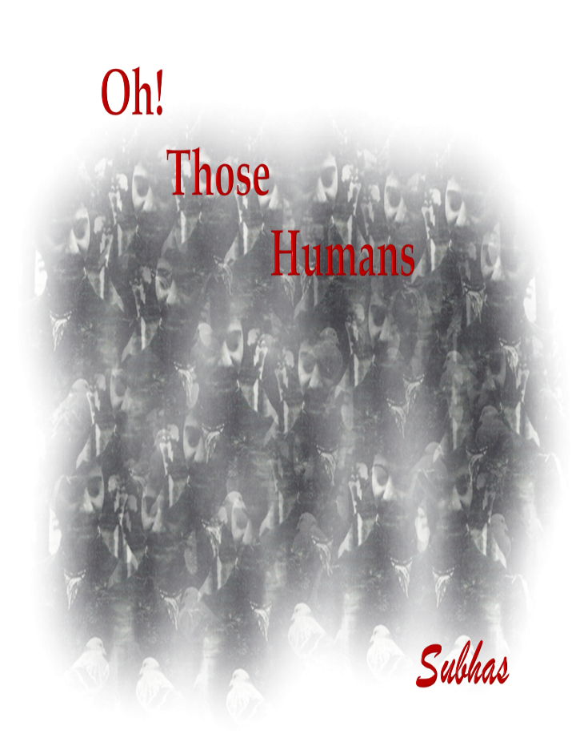
Oh! Those Humans is a satiric-poetic commentary on human presumptions and interactions with people, animals and the earth. The poems range from insensitivity towards life and death, to the alienation of individuals for linguistic and ideological differences and for survival that leads to isolation.
He knew that he was not the only one
whose voice had dried in the heat
He saw the bodies of those who were sent to die
and the bodies that the earth must eat

The omnipotence of a Peace Maker is expressed as:
I bring peace to the victor with killing machines
cleaning the land of unsavoury beings
while the Slave Master promise is:
I am your savior let me shake your hand
let me take your children to the promised land
Both fall into the human frailty of egotistical prominence and power within a selfish aura, but the focus is on ephemeral power, accolades and business without human consideration.
A modern-day concern is the advancement of science and the manipulation of genetics as the salvo for all human ailments. My Body, My Choice is a satirical play on vaccinations and the questions of whether to ‘Vaccinate or Vaccinot’. The answers are debatable and personal as are the diseases and outcomes.
Man is the guardian of the land but there is a clash of ownership with the animals. In “Kill the deer, My Dear” the deer is presented as fierce animal, a menace eating the fruit and flowers of human endeavour and, therefore, they must be eliminated.
The Homeless reflects upon the gift of life while the starving child cries out,
Give me water, Give me Bread; Give me food before I’m dead.
Human ingenuity is changing the art of war. Drones are the soldiers with no feeling and no loss so that the killing can be triggered without seeing or knowing the enemy.
Somewhere they are building
beyond the lumbering machines
that will vaporize the humans
and leave the landscape green
In Mind Design the sentiment is not to change the mind of the individual but the vision.
Change the vision not the mind
And leave the crumpled images behind
And what of the future?
Who will remember there was a planet once
That circled the sun in a seasonal dance
That was filled with life and gifted faces
But lost it’s soul to war-torn spaces

Homeless

Oh! You Human
Hear my cry in my dying mind
as you drive past my ghostly shape
Why have I been lost to an open sky
with tattered clothes and an unkempt face?

I feel the sun set on my drowsy eyes
but cannot sleep for fear of death
I am a throw-away like a footless sock
and you see me as if I was born today

I ran free once in the sun-lit air
till the darkness dropped upon me
Those whom I knew had changed the shape
and I was no longer free

Caged in small and filthy homes
hardened like a mindless stone
I broke to keep this body alive
built on chance and the need to survive

The roof was gone and the walls fell down
I was married to the wind and the rain
My food was anything I found
My take was what I could see and find

The gang was solace for the gift of life
and I floated without care to kill my time
The body was dying and I was crying
to an unknown God and a tortured life

The gang was gone and I was alone
to walk on crippled feet
to taste the crumbs of a homeless bum
with no skills to change my suit

I wanted some reprieve before I died
to taste a sweetened day
and feel the warmth of a living earth
and the treasure of a thoughtless birth

Oh! Human
Can you feel my warm bed on a frosty night
with the heat of a body cold
In the dark night of an open home
and a story never told

I could have walked with you, Oh! Human
but my chance of life was gone
The stars had marked a pathetic trail
to dust me to an end

I know not the path in this lost life-scape
I know no alien God to lead the way
I know no reason to linger on
and wait to break this unfinished game

I know not how to kill the life
that carries this body senselessly
and I must display my figure to time
on this shattered ground breathlessly

Oh! Human
I cannot dream without a hand
the words of a thoughtful smile
set your mind at peace
and pray to your weekend God

My forgotten God in a restless form
shifts as the light gets darker
I lived once and will be forgotten
with only a stick for a marker

Oh!
Human
I was a Human Once

2025

