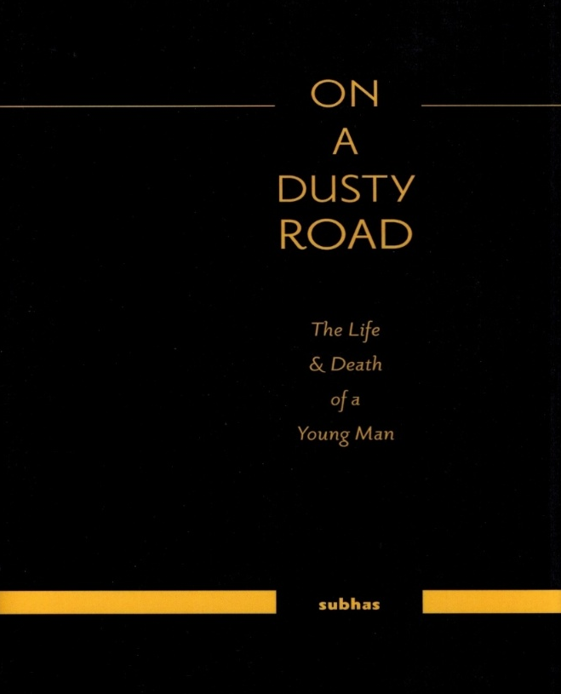
“Set in a South African back-drop”

A Humorous; Contemplative; Sad & Imaginative Tale of Two Boys.

“The story of their lives and a community’s hopes & aspirations on the promise and success of a young man”
This is a documentary-novel that constructs the life and death of a promising young man.

The fictionalized story is told through the recollections of those who knew Ravi; the young man’s lessons about life and death; about education and politics. Ravi’s life is revealed through short, impressionistic episodes and is enmeshed with his close friendship with Sunny and the Dusty Road Boys.

Part I follows the childhood escapades of the two friends. Sunny’s 'joie de vivre' and Ravi’s staid character are drawn into imagination and entrepreneurship when Ravi is given a bicycle.
Part II exposes Ravi’s sheltered life on the Dusty Road when he meets Daniel who is killed in an accident and learns of Sunny’s death as a 'murder for science'.
In Part III the community coalesces to nurture Ravi's abilities with the expectation that he would bring recognition and change to the people on a Dusty Road, but life has its own destination.

A GIFT

The gift of life is life itself but to a young boy only the tangibility of a gift is what really counts. Possession is the reality; possession is the identifier; possession is the acknowledgement of being alive; being noticed. The item is the reality and as an item is passed from one user to another there is wonderment for the new user and within a community that had so little a new-used item is an accumulation of pride, status and wealth.

THE END OF A BEGINNING

The fire of life had died but time seemed to circle in its own sad path where memory and images; stories and snippets were said and repeated to hold onto the short life of a young man. A young man of promise, of value and expectation; a young man with an old soul and now like the cold ashes of the havan ceremony his body was turned into ash.
The women, in white saris, walked silently from one table to another preparing the meal for the men who had gone to the crematorium. The women had come to provide comfort and consolation to the mother whose son was the son of the community; the young man who in the eyes of an emerging community had the potential to escalate the dreams of their children, their grandchildren and those to be born.
The men arrived crammed in cars and trucks; men the young man might have seen but not known; men who had heard of the young man but never had the opportunity to speak with him or touch him with their admiration. He was the boy and the man of the community.
The pundit in his white dhoti and sandals was given a basin of water to wash his face and hands, an ablution marking the conclusion of a sad event. He sat on one of the very few chairs available and removed his sandals. Water was poured over his feet and dried with a small white cloth. He was the guide through his Sanskrit Mantras to lead the soul into the next cycle of life.
The men washed their faces and hands and feet at the outdoor tap and one by one they sat and slowly the hum of their voices began to fill the open space. The talk was about the tragedy; the loss of a young life; the loss of the spirit that the community had begun to congeal around. And when the talk drifted to the loss a mother experiences; the enduring sadness; the gift given and taken the pundit spoke out.

www.friesenpress.com
2016

