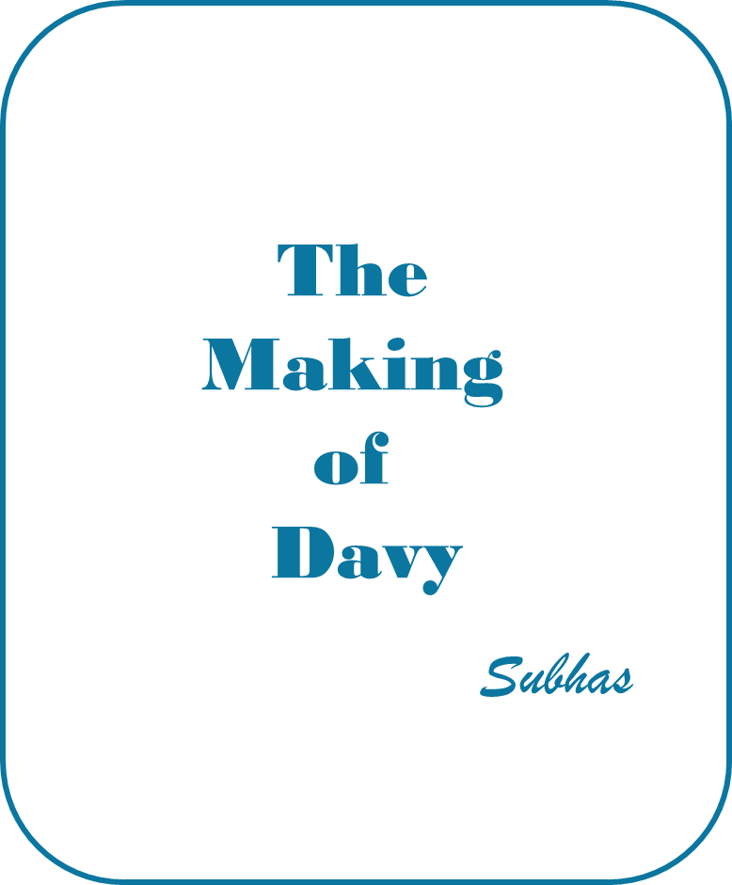
The Making of Davy is an encounter between a prostitute, Risa, and a paraplegic in an electric wheelchair, Davy.
The conversation flows between Davy’s dysarthric speech, speech that is difficult to understand at times, and his communication device.
Davy’s world is confined to his apartment and he reaches out to the world through a pair of binoculars.
He watches the actions and interactions of the street below and focuses on a young prostitute, Risa.

She has observed Davy watching her and has come to the conclusion that Davy is spying on her and confronts him.
The tension of the encounter subsides and Davy has his first sexual experience but it is not co-habitation; however, it is his first experience of the sex-drive.
The second half of the play is an uneven balance of compassion and anguish that leads to Risa committing suicide and Davy left in despair.
Unpublished

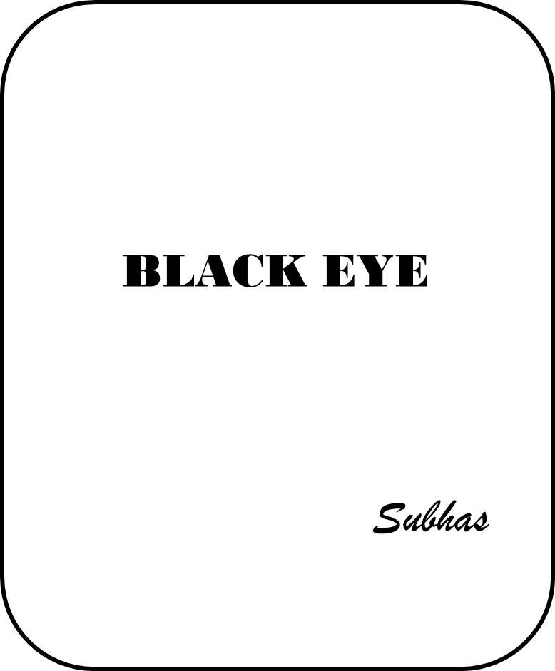

The Play is a focus on a moment of compassion in a conflict zone that leads to the death and destruction of a family.
While the play expresses the changes and frustrations within the family the reality is that the eldest son, the editor of a local newspaper, has been brutalized to a non-entity by the political and security system.
The mother, a second son and daughter share the anguish of living in an oppressed society and a violent regime.

The youngest son, Nels, has no interest or understanding of the socio-political struggle and is wrapped in the daily experiences of the unemployed youngsters engaged in alcohol, drugs, gambling and a code of violence and survival.
Nels innocently assists an opposition leader to the regime and the family is drawn into a direct confrontation with the security police and the result is swift and catastrophic.
In the final scene the matriarch of the family stands in front of a barricade in defiance of the regime and is gunned-down.
The audience is left to judge the power of violence and the question of justice.
Unpublished


“Voices” expresses the struggle to survive – a universal cry and the flow of life of the ‘untouchables’
The voices are the voices of history - the living and the dead. Voices that will continue to reverberate; voices forever… until the humanity of man restores the ‘humanity of man’

The Cast
There is no single identifiable actor but a group of as many that are selected for the play and they work as a chorus and with slight changes, a mask; a change of clothing; the inclusion of a single item – a hat or a shawl; that actor is the voice for the individual part.
Unpublished

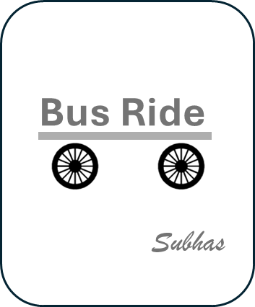
This is a short encounter on a bus between a crusty passenger and an eager conversationalist. The conversationalist raises many topics to pass the flow of the journey but the passenger is disinterested in maintaining the interaction.

Bus Ride was presented at the University of Wisconsin, Madison, by the University of Minot, ND, Drama Department in 1973.

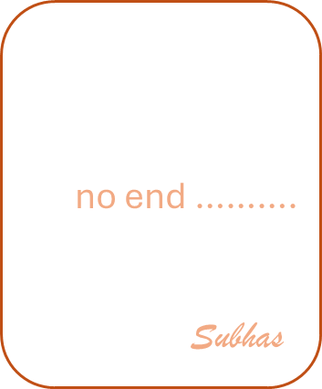
Idle interactions and absurdity. There is no theme, no drama, no substance; but the continuation of time and the need to establish some identity. This is done through insipid questions and responses; absurd actions and reactions.
no end expresses what life is when purpose is lost and time is merely a passage of time to no end…..

This was the first play written in Canada (1969) and was the instrumental in Subhas staying in Canada.
“Write me a play and I’ll find you a job”. The agreement led to Subhas’ first job in Canada as a Speech Consultant.

